HW7 - Testing

Dennis Martin Vivas

ACS 567 Software Project Management

**1. Unit test for method in Feature A:**

**Method:** validate_average_velocity(): In case there is an error prints error and returns false, in case there is no error for calculation, returns team’s average velocity and returns true.

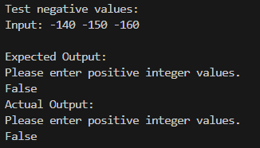

**2. Unit test for method in Feature A:**

**Method: validate_positive_integer():** In case there is an error prints error and returns false, in case there is no error for calculation, returns true.

**3. Acceptance test for Feature A:**

**Given the user is prompted to enter past velocities separated by space.  
When the user provides valid past velocities (e.g., "140 150 160") and presses Enter.  
Then the system should calculate the average velocity of the provided sprints,  
And the system should display the average velocity to the user,  
And the system should exit.**

**4. Acceptance test for Feature B:**

**Given the user is prompted to enter the number of team members.  
When the user provides a valid number of team members (e.g., 5) and presses Enter.  
And the user is prompted to enter details for each team member (days off, hours committed to scrum activities, available hours per day).  
When the user provides valid details for each team member and presses Enter after each input.  
Then the system should calculate the total available effort-hours for the team,  
And the system should display the total available effort-hours to the user,  
And the system should exit.**